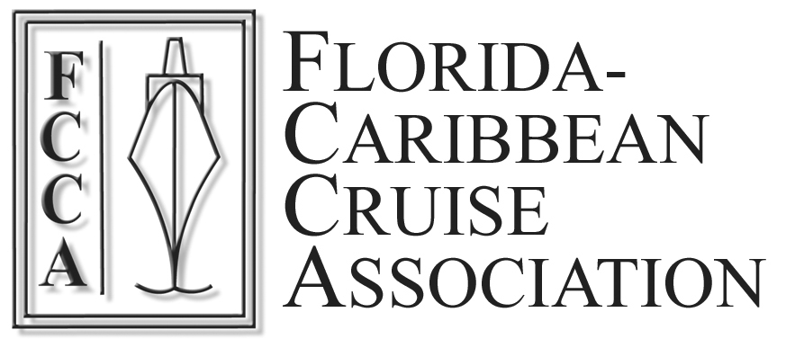

ARE YOU PROPERLY ADDRESSED?

If not, please tell us! It will only take a few seconds.

Dear Industry Partner:
The Member Lines of the FCCA would greatly appreciate if you could take a few seconds to complete the following contact information. Please print or type all information and return to us at your earliest convenience via fax (954) 441-3171, by mail to the address above or fill out the online Database Correction form at. http://www.f-cca.com/dbc.html.

Your Name: Mr. Mrs. Ms.
Your Job Title:
Company/Organization
Street Address:
City State/Parish/Providence:
Country: Zip/Postal Code:
Telephone: Fax:
E-mail:

1. Nature of your Business?
Port Authority Supplier Tour Operator
Port Agent Tourism Agency Other

2. Additional Contact(s):
Name: Mr. Mrs. Ms
Job Title:
E-mail:

Name: Mr. Mrs. Ms.
Job Title:
E-mail:

After this form is completed, attach it to an e-mail addressed to fcca@f-cca.com

Thank you for your time.

